3rd JUNE 2026
//INSERT ONE
import com.mongodb.client.*;
import com.mongodb.client.model.Filters;
import com.mongodb.client.model.Updates;
import org.bson.Document;
public class crud_operations {
public static void main(String[] args) {
// Connect to MongoDB
MongoClient mongoClient = MongoClients.create("mongodb://localhost:27017");
// Access database
MongoDatabase database = mongoClient.getDatabase("CollegeDB");
// Access collection
MongoCollection<Document> collection =
database.getCollection("Students");
// ==========================
// CREATE (Insert)
// ==========================
Document student = new Document("id", 101)
.append("name", "Likhitha")
.append("department", "CSE")
.append("cgpa", 8.7);
collection.insertOne(student);
System.out.println("Document Inserted Successfully");
// ==========================
// READ (Find)
// ==========================
System.out.println("\nStudent Records:");
FindIterable<Document> students = collection.find();
for (Document doc : students) {
System.out.println(doc.toJson());
}
// ==========================
// UPDATE
// ==========================
collection.updateOne(
Filters.eq("id", 101),
Updates.set("cgpa", 9.2)
);
System.out.println("\nDocument Updated Successfully");
// ==========================
// READ Updated Record
// ==========================
Document updatedStudent =
collection.find(Filters.eq("id", 101)).first();
System.out.println("\nUpdated Record:");
System.out.println(updatedStudent.toJson());
// ==========================
// DELETE
// ==========================
collection.deleteOne(Filters.eq("id", 101));
System.out.println("\nDocument Deleted Successfully");
// Close connection
mongoClient.close();
}
}

OUTPUT:

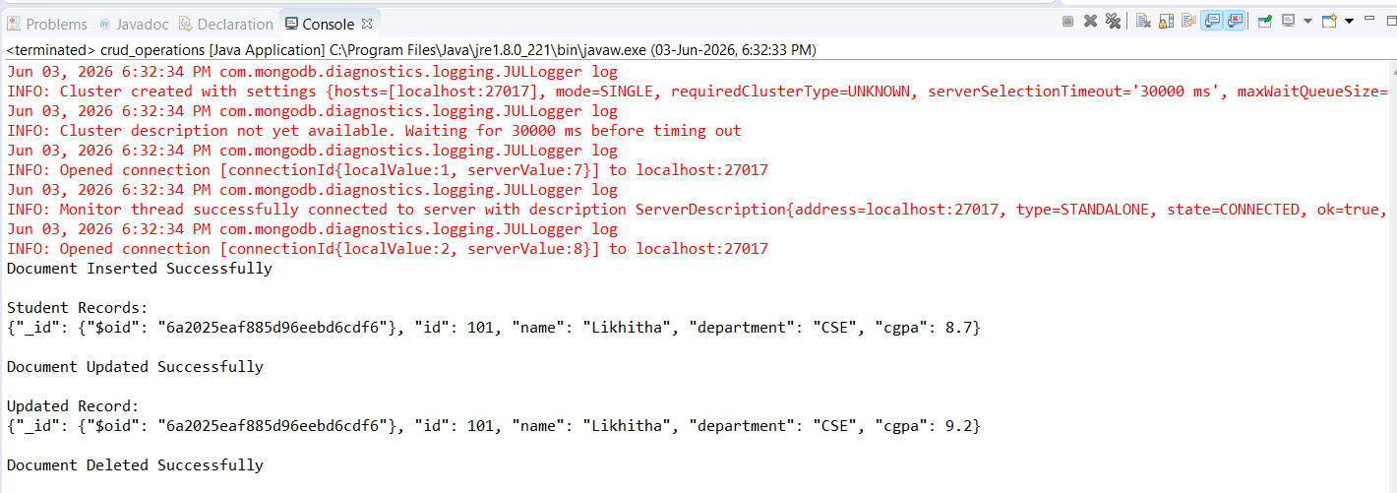

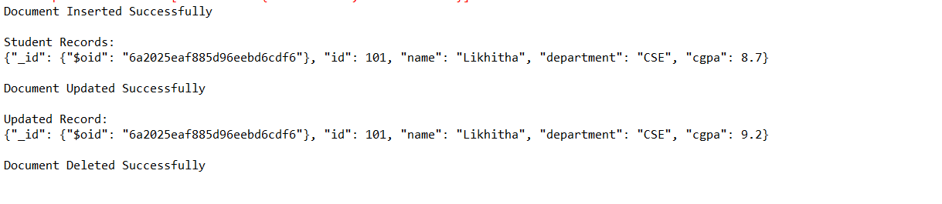

import com.mongodb.client.*;
import com.mongodb.client.model.Filters;
import com.mongodb.client.model.Updates;
import org.bson.Document;

public class crud_operations {

public static void main(String[] args) {

// Connect to MongoDB
MongoClient mongoClient = MongoClients.create("mongodb://localhost:27017");

// Access Database
MongoDatabase database = mongoClient.getDatabase("CollegeDB");

// Access Collection
MongoCollection<Document> collection =
database.getCollection("Students");

// Clear old records to avoid duplicates
collection.deleteMany(new Document());

// ==========================
// CREATE (Insert Many)
// ==========================
collection.insertMany(java.util.Arrays.asList(
new Document("id", 1).append("name", "Likhitha"),
new Document("id", 2).append("name", "Devansh"),
new Document("id", 3).append("name", "Rudra")
));

System.out.println("Documents Inserted Successfully");

// ==========================
// READ (Find All)
// ==========================
System.out.println("\nStudent Records:");

FindIterable<Document> students = collection.find();

for (Document doc : students) {
System.out.println(doc.toJson());
}

// ==========================
// READ (Find Specific Document)
// ==========================
Document student = collection.find(Filters.eq("id", 2)).first();

System.out.println("\nSpecific Document:");
System.out.println(student.toJson());

// ==========================
// UPDATE
// ==========================
collection.updateOne(
Filters.eq("id", 2),
Updates.set("name", "Devansh Koushik")
);

System.out.println("\nDocument Updated Successfully");

// ==========================
// READ Updated Record
// ==========================
Document updatedStudent =
collection.find(Filters.eq("id", 2)).first();

System.out.println("\nUpdated Record:");
System.out.println(updatedStudent.toJson());

// ==========================
// DELETE
// ==========================
collection.deleteOne(Filters.eq("id", 2));

System.out.println("\nDocument Deleted Successfully");

// ==========================
// READ Remaining Documents
// ==========================
System.out.println("\nRemaining Documents:");

FindIterable<Document> remainingStudents = collection.find();

for (Document doc : remainingStudents) {
System.out.println(doc.toJson());
}

// Close Connection
mongoClient.close(); }

OUTPUT:
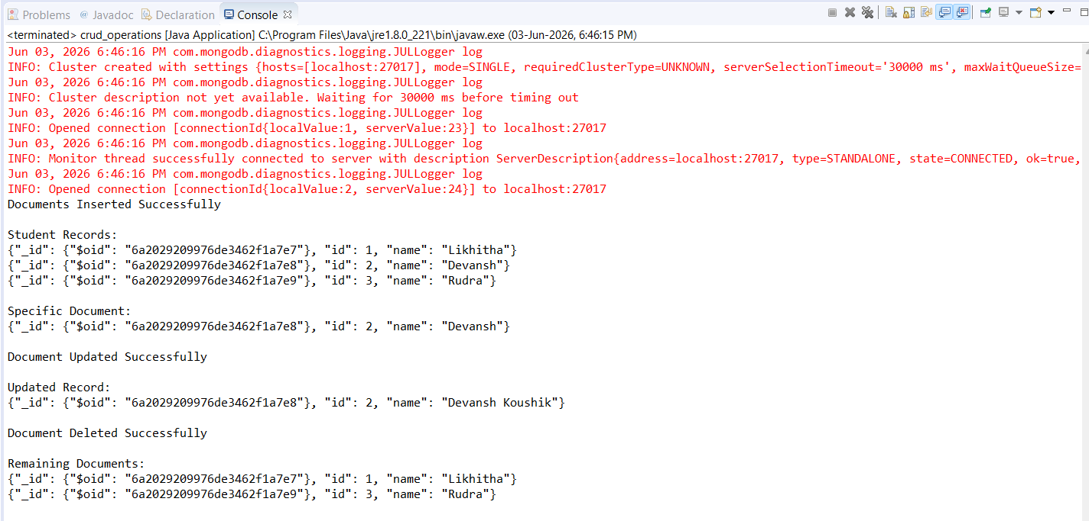

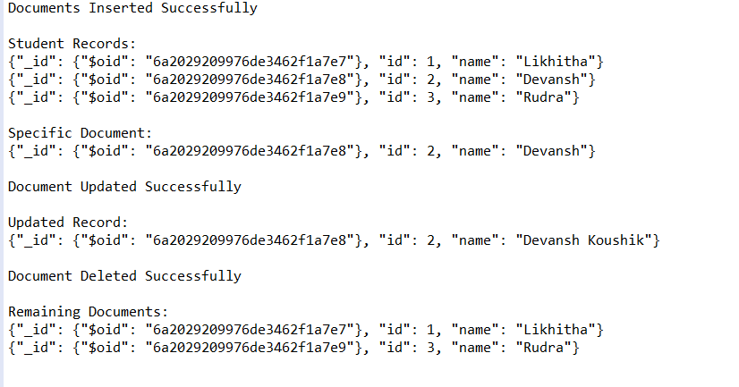

//INSERT MANY
import com.mongodb.client.*;
import com.mongodb.client.model.Filters;
import com.mongodb.client.model.Updates;
import org.bson.Document;

import java.util.Arrays;

public class crud_operations {
public static void main(String[] args) {

// Connect to MongoDB
MongoClient mongoClient = MongoClients.create("mongodb://localhost:27017");

// Access database
MongoDatabase database = mongoClient.getDatabase("CollegeDB");

// Access collection
MongoCollection<Document> collection =
database.getCollection("Students");

// ==========================
// CREATE (Insert Many)
// ==========================
Document student1 = new Document("id", 101)
.append("name", "Likhitha")
.append("department", "CSE")
.append("cgpa", 8.7);

Document student2 = new Document("id", 102)
.append("name", "Devansh")
.append("department", "ECE")
.append("cgpa", 8.9);

Document student3 = new Document("id", 103)
.append("name", "Rudra")
.append("department", "IT")
.append("cgpa", 8.5);

collection.insertMany(Arrays.asList(student1, student2, student3));

System.out.println("Documents Inserted Successfully");

// ==========================
// READ (Find All)
// ==========================
System.out.println("\nStudent Records:");

FindIterable<Document> students = collection.find();

for (Document doc : students) {
System.out.println(doc.toJson());
}

// ==========================
// UPDATE (Update Many)
// ==========================
collection.updateMany(
Filters.in("name", "Likhitha", "Devansh", "Rudra"),
Updates.inc("cgpa", 0.5)
);

System.out.println("\nDocuments Updated Successfully");

// ==========================
// READ Updated Records
// ==========================
System.out.println("\nUpdated Records:");

FindIterable<Document> updatedStudents =
collection.find(Filters.in("name", "Likhitha", "Devansh", "Rudra"));

for (Document doc : updatedStudents) {
System.out.println(doc.toJson());
}

// ==========================
// DELETE (Delete Many)
// ==========================
collection.deleteMany(
Filters.in("name", "Likhitha", "Devansh", "Rudra")
);

System.out.println("\nDocuments Deleted Successfully");

// Close connection
mongoClient.close();
}
}
OUTPUT:
